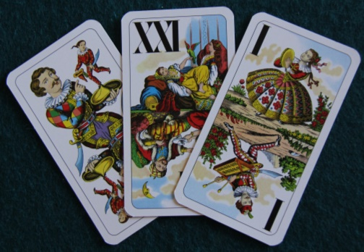
Tapp Tarock
Viennese Tappen or Tapper – earliest Austrian
54-card Tarock game, first recorded 1800,
first described 1821 (Dorset rules 2021)
3 players, Tarock pack (54 cards), anticlockwise, 20 min/deal
Aim. Score ≥35⅔ card points & as many bonus points as possible
Deal. Deal 2 packets of 8 each, in fours, (16 if cutter knocks), then 6 to the talon.
Card Ranking K Q C J 10 9 8 7 K Q C J 1 2 3 4 Tarocks: Sküs, XXI–I
Bidding. Forehand opens with any positive bid, i.e. a Tapper, Dreier, Unterer, Oberer or Solo. Unless forehand bids Solo, the next player may either pass by saying “good” (gut) or bid higher. If a player is outbid, he may immediately “hold” (selbst); otherwise must say “good”. A Solo may not be held by someone who only bid a Tapper. The bid winner becomes the declarer and plays against the two defenders.
Contract | Pts | Remarks
Tapper | 2 | Exposes whole talon and makes 6 discards
Dreier (“three”) | 3 | Exposes talon & takes top or bottom packet of 3
Unterer (“lower”) | 4 | Exposes talon but picks up lower packet only
Oberer (“upper”) | 5 | Exposes talon but picks up upper packet only
Solo | 8 | No exchanging; talon not used
N.B.: discards belong to the declarer; unused talon cards to the defenders
Except in a Solo, the declarer exposes all 6 talon cards. In a Tapper, he picks up the talon and lays away 6 discards, face down. In a Dreier, he chooses either talon half; in an Unterer or Oberer he takes the lower or upper half respectively. In all 3 cases, the declarer discards 3 cards and the other half of the talon goes to the defenders. Kings or Trull cards may not be discarded; nor any Tarocks unless there is no choice, in which case they must be shown to the opponents. In a Solo, the talon is not exposed and goes to the defenders unseen.
Announcements. Before play begins, the declarer may announce:
- Pagat ultimo – a commitment to take the last trick with Tarock I. If announced, it may not be played earlier unless there is no option.
- Valat – a commitment to take all tricks. As soon as the declarer loses a trick, play ends and the declarer has lost.
If successful these earn bonuses – see over. The game and announcements may be doubled with Contra, Recontra and Supercontra. House rule: Contra.
Play. Players note down any hand bonuses they have (see over). Declarer makes any announcements; then says “ready” (es liegt). Forehand leads to the first trick and the winner of the trick leads to next. Players must follow suit or, if unable, play a tarock. If neither is possible, they may play any card. There is no requirement to head the trick. A trick is won by the highest card of the led suit, or highest tarock if any are played.
Scoring. Tot up card points using the normal Tarock scheme i.e. group cards in threes; add up card points in each packet of three and deduct 2. Any remaining skartins are worth ⅓ pt each and the total rounded to the nearest integer. The declarer needs 36 card points to win the deal.
Bonuses. Bonuses are awarded as per the table. Hand bonuses are awarded for cards held in the hand before play starts i.e. may include cards picked up from the talon. Note that a Pagat ultimo is not awarded if a defender captures the Pagat from his partner.
Bonuses | Bonus pts | Description
Heads (Köpfe) | 1 | 2 honours in the hand
Tarock Trull | 3 | All 3 honours in the hand
Royal Trull | 3 | All 4 Kings in the hand
Pagat ultimo | 4 | Tarock I takes last trick
Pagat ultimo announced | 8 | ditto
Pagat ultimo in Solo | 8 | ditto
Pagat ultimo ann. in Solo | 16 | ditto
Valat | 12 | Slam – all tricks taken
Valat announced | 24 | ditto

Game Points. Game points are awarded as shown below. If the declarer loses, each defender wins the game value shown. Players then declare any hand bonuses and add all bonuses to their game points for their final score. If an announced bonus is lost, it goes to each of the defenders. House rule: game is 16 or 24 as agreed.
Contract | Game pts | Contract | Game pts
Tapper | 2 | Unterer | 4
Dreier | 3 | Oberer | 5
 |  | Solo | 8
Terminology
Cards | Names
Sküs, Mond, Pagat | Trull
The Fool | Sküs, Stieß, Gstieß
Tarock XXI | Mond
Tarock I | Pagat, Spatz
Tarock II | Uhu,
Tarock III | Kakadu, Pelikan, Kanari, Gickerl
Tarock IV | Quapil, Lämmergeier, Geierwally, Wildsau
Low cards | Skartins, Skartindels, Skatindels, Glatzen
Pip cards | Ladons, Latons

N.B. These rules are based on Alscher (2003) with the variations he mentions for Tapper (a contract from the earliest form of the game) and the more difficult versions of Unterer and Oberer contracts.

